Stock Price Prediction Using Machine Learning

By

***21781A33C4 (R Pavithra)***

***21781A33D0 (S Soniya)***

***21781A33D1 (Sanjana K)***

***21781A33E9 (V Naga Shanthi)***

*Guided by*

***Prof. Ms Raasha***

A Dissertation Submitted to

SRI VENKATESWARA COLLEGE OF ENGINEERING AND TECHNOLOGY, An Autonomous Institution affiliated to ‘JNTU Ananthapur’ in Partial Fulfilment of the Bachelor of Technology (***Computer Engineering***) with Specialization in ***Artificial Intelligence and Machine Learning.***

*May 2024*



**SRI VENKATESWARA COLLEGE OF ENGINEERING AND TECHNOLOGY**

**R.V.S. Nagar Tirupathi Road, Andhra Pradesh– 517127**

***Model Building***

Now our data is cleaned and it’s time to build the model. We can train our data on different algorithms. For this project we are applying seven classification algorithms. The best model is saved based on its performance.

**Linear Regression Model**

First we are going to initialise the LinearRegression() model and training data is passed to the model with.fit() function. Test data is forecasted/predicted with predict() function and saved in a new variable. For evaluating the model, train score, test score, r2_score and MAE scores are used.

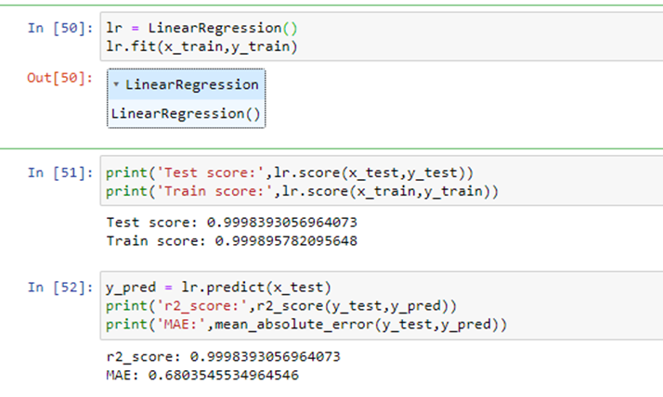

### *Decision Tree Regressor*

First we are going to initialise the DecisionTreeRegressor () model and training data is passed to the model with.fit() function. Test data is forecasted/predicted with predict() function and saved in a new variable. For evaluating the model, t

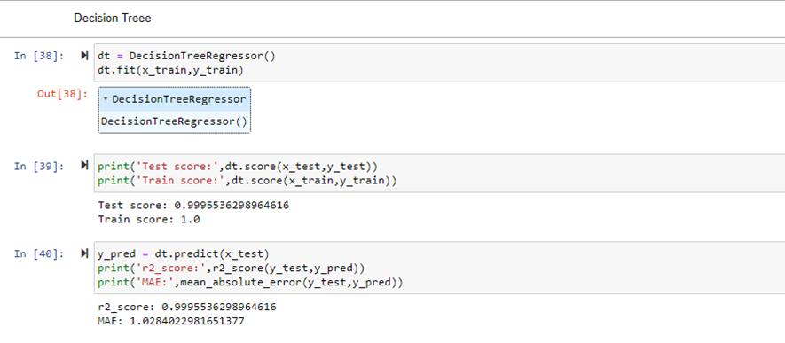

### ***Extra Trees Regressor***

First we are going to initialise the ExtraTreeRegressor () model and training data is passed to the model with.fit() function. Test data is forecasted/predicted with predict() function and saved in a new variable. For evaluating the model, train score, test score, r2_score and MAE scores are used.

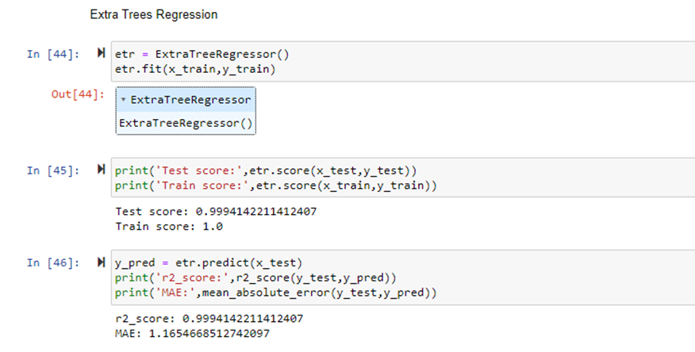

### ***Random Forest Regressor***

First we are going to initialise the RandomForestRegressor () model and training data is passed to the model with.fit() function. Test data is forecasted/predicted with predict() function and saved in a new variable. For evaluating the model, train score, test score, r2_score and MAE scores are used.

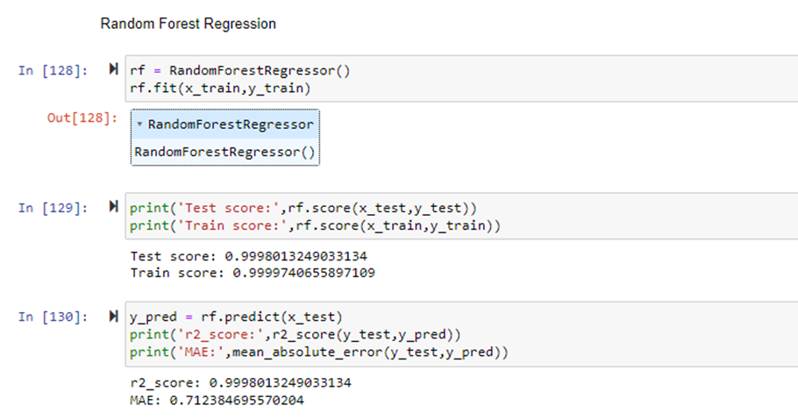

### ***Model Comparison And Evaluating Best Model***

From the observed r2 scores and Mena absolute errors we can clearly see that the linear regression model has least Mean absolute error among others. So we are going to select Linear Regression model for final Flask application deployment.

To plot the predictions over the original values of all the companies we can use the following code.

First, we are going to store the dates, original closing prices of stocks and predicted closing prices of stocks as shown below. We are going to access company specific rows of test_data and x_test variables using the “Company” column.

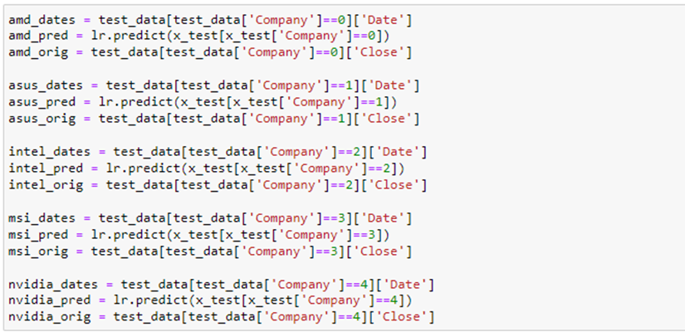

Now using these columns we are going to plot the data as shown

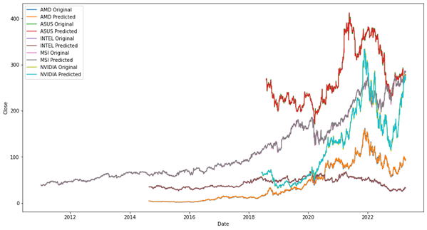

As we can see the lines plotted by the predicted and original data are almost perfectly overlapping.

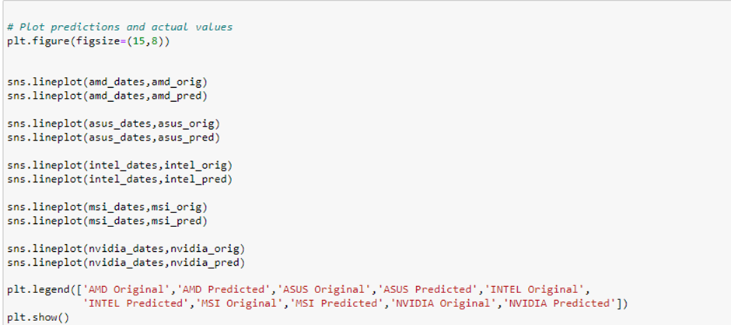

The model which is used for this project is Linear Regression as it is evaluated as the best suitable model for estimating the stock price for the top 5 GPU companies according to the results after comparison of the models.